Course Code: CSA1557

Course Name: Cloud Computing and Big Data Analytics

S.PRAKUL 192210073

10) Create a simple cloud software application for online super market using any Cloud Service Provider to demonstrate SaaS with the template of customer name, address, phone, email, items, quantity etc. with the item classification form.

AIM: To Create online super market using any Cloud Service Provider to demonstrate SaaS.

PROCEDURE:

step1: Go to zoho.com.

step 2: Log into the zoho.com.

step 3: Select one application step.

step4: Enter application name as library book reservation system.

step 5: Created new application as library book reservation system.

step 6: Select one form

step 7: The software has been created.

IMPLEMENTATION:

STEP1: GOTO ZOHO.COM

STEP 2: LOGIN TO THE ZOHO.COM

STEP 3: SELECT ONE APPLICATION

STEP 4: ENTER APPLICATION NAME

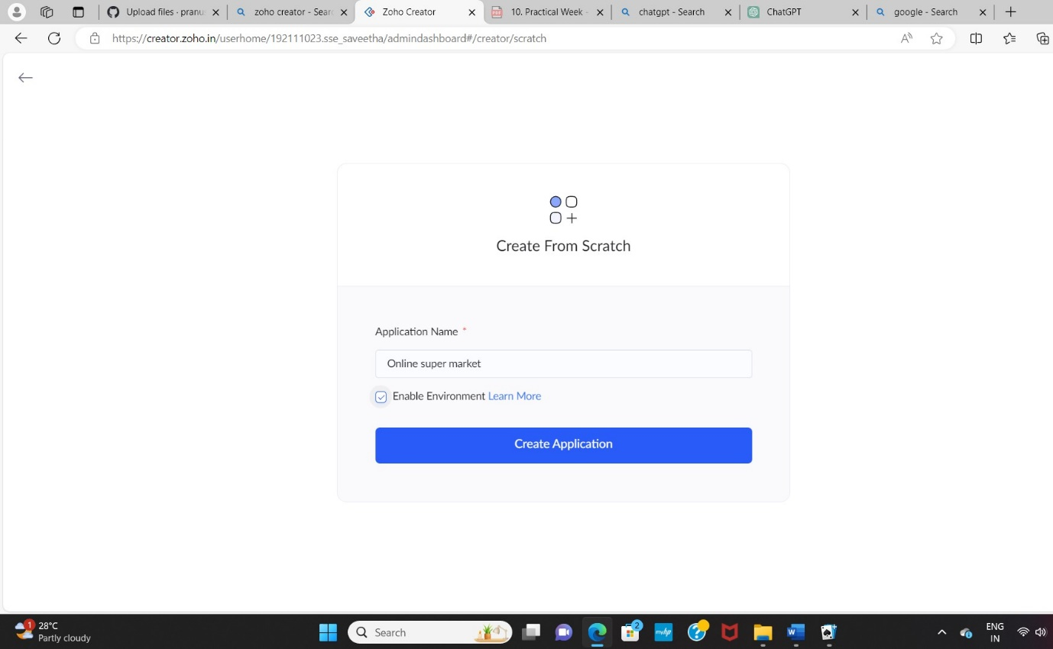

STEP 5: CREATED NEW APPLICATION

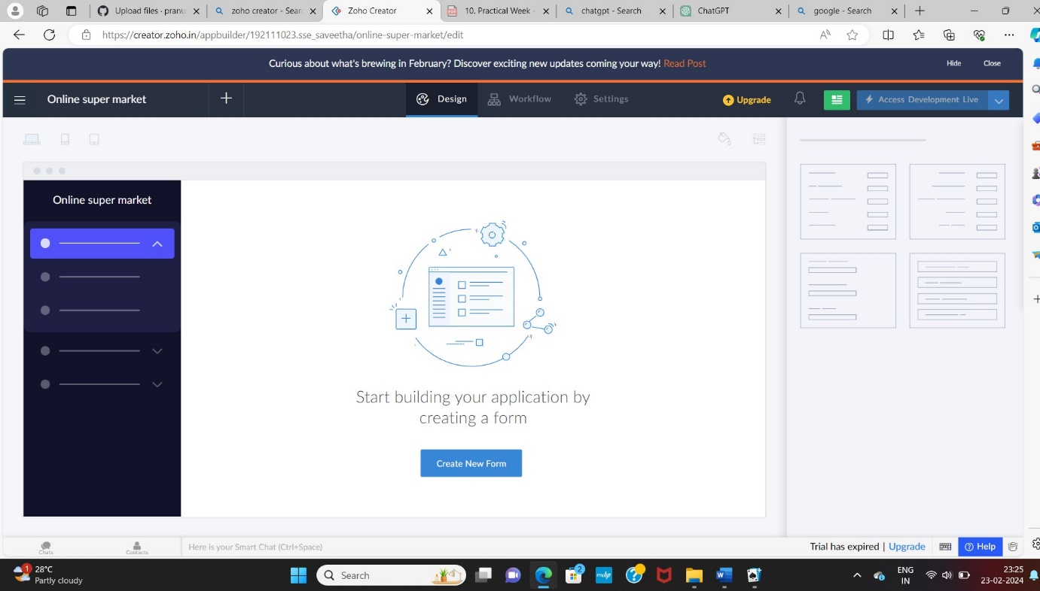

STEP 6: Select from Stratch and Create form as login.

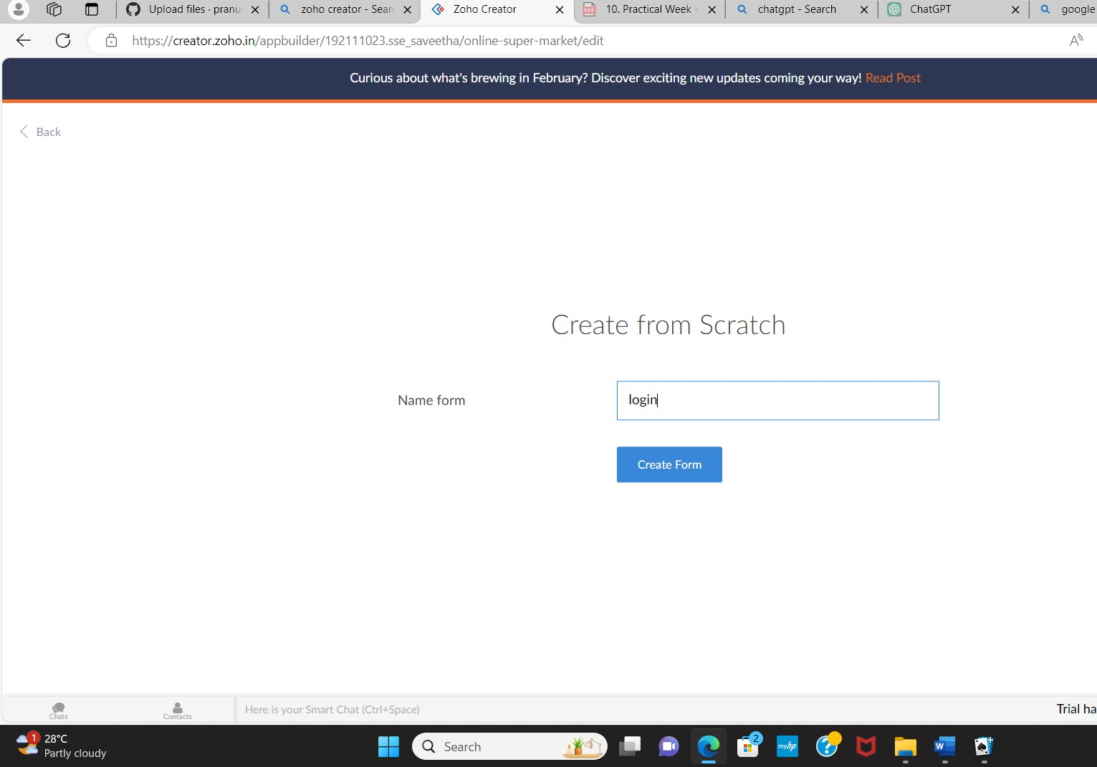

STEP 7: The form has been created as login.

Choose the fields.

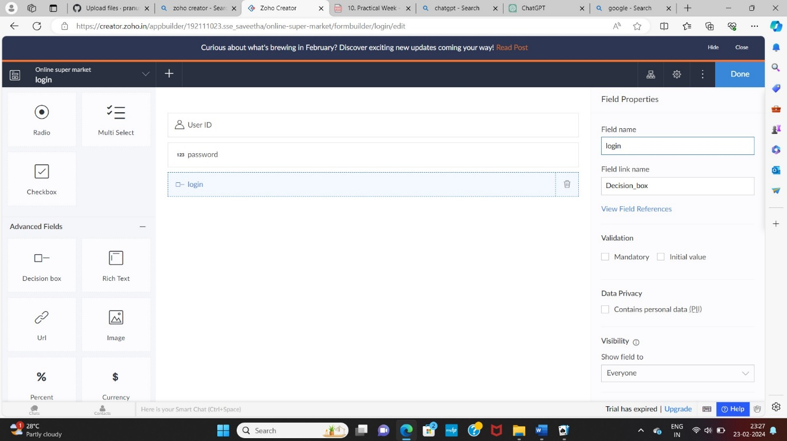

STEP 8: Click Access Development Live and enter the details to access.

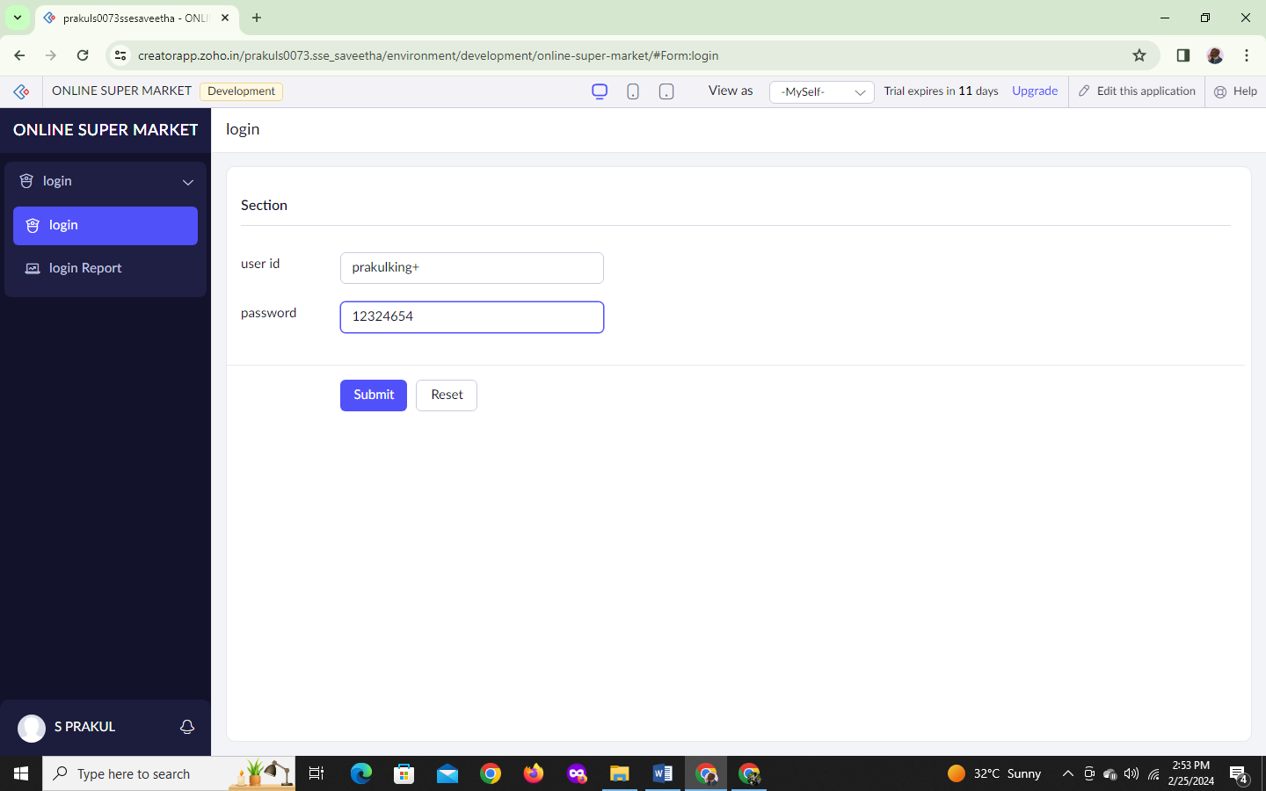

STEP 9: The report has been registered in the login report.

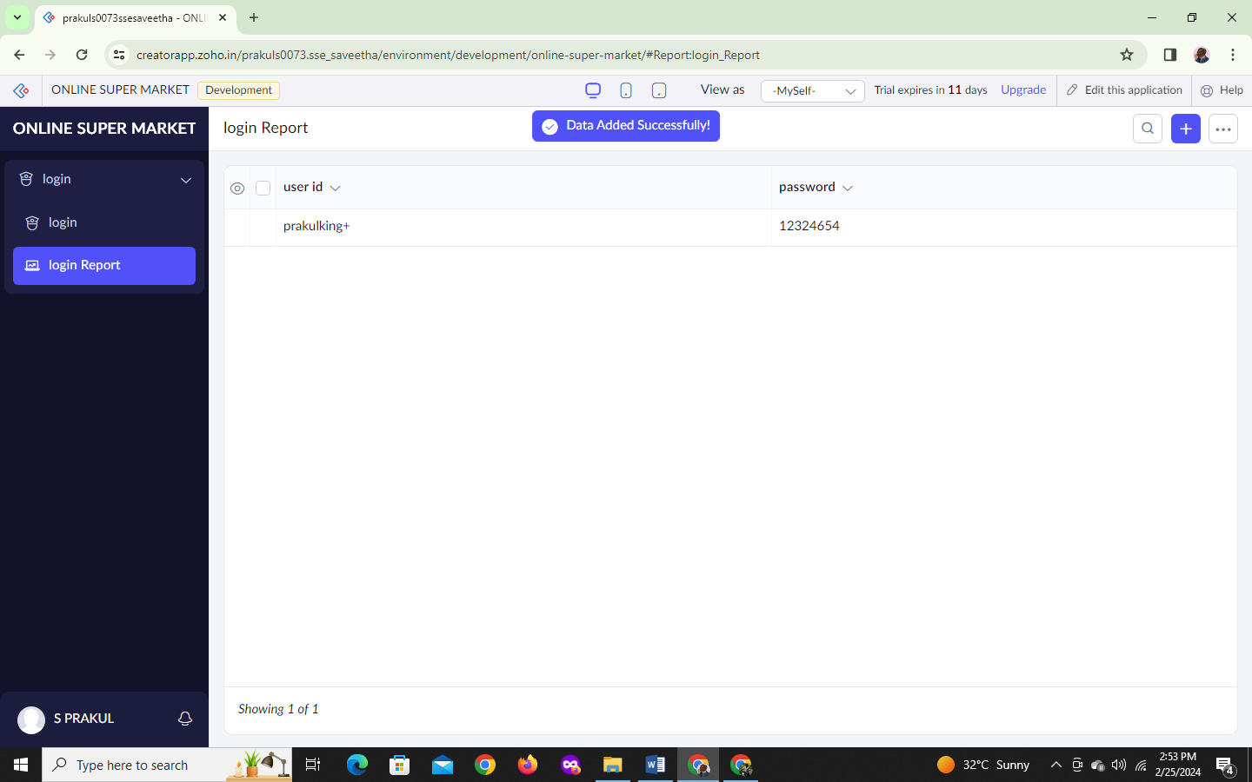

STEP 10: Select from Scratch and Create form as Customer details.

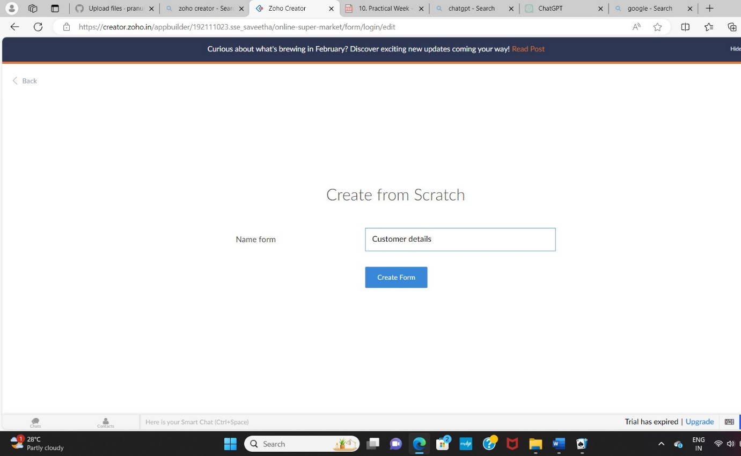

STEP 11: The form has been created as Customer details.

Choose the fields.

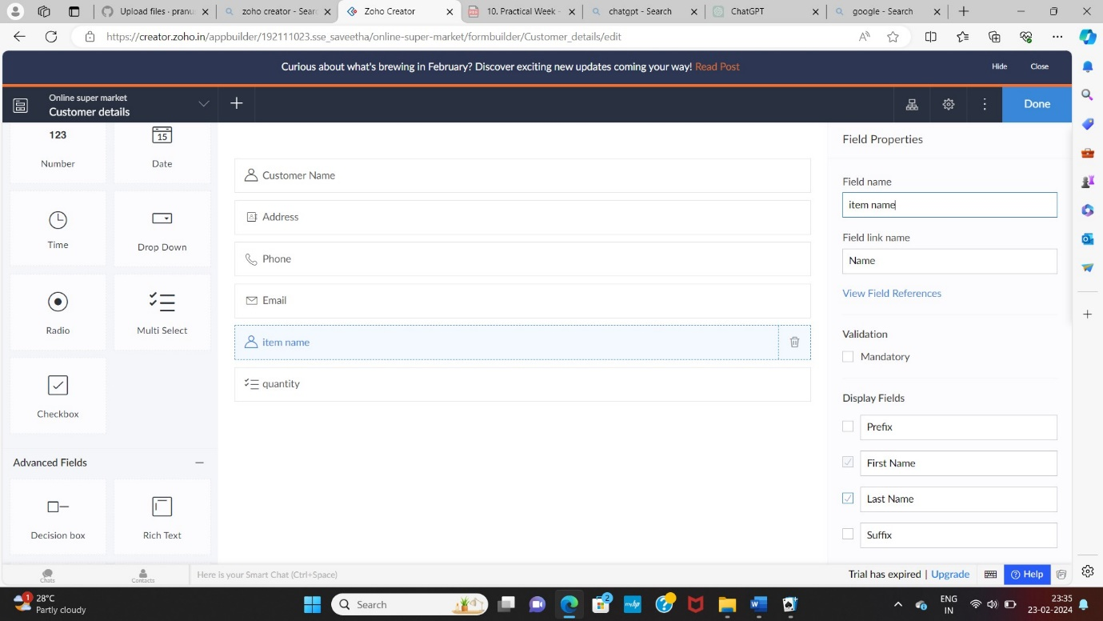

STEP 12: Click Access Development Live and enter the details to access.

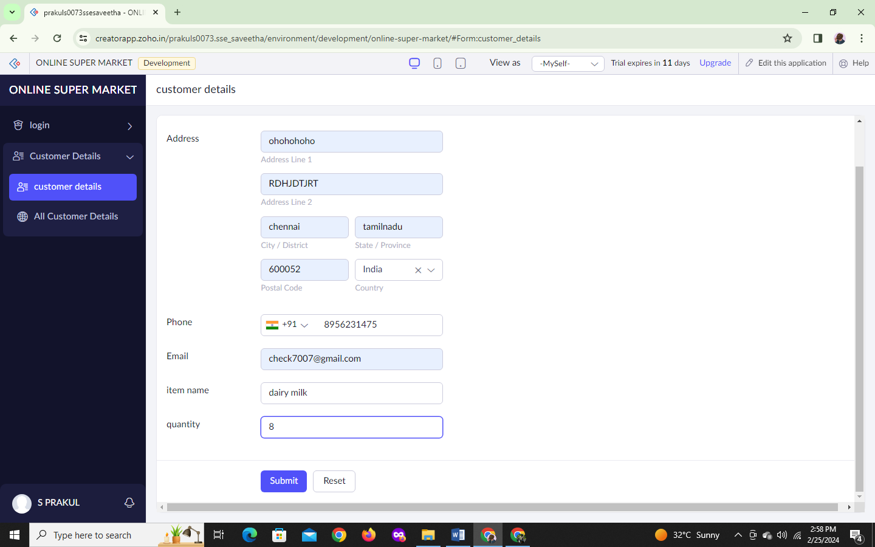

STEP 13: The report has been registered in the customer details report.

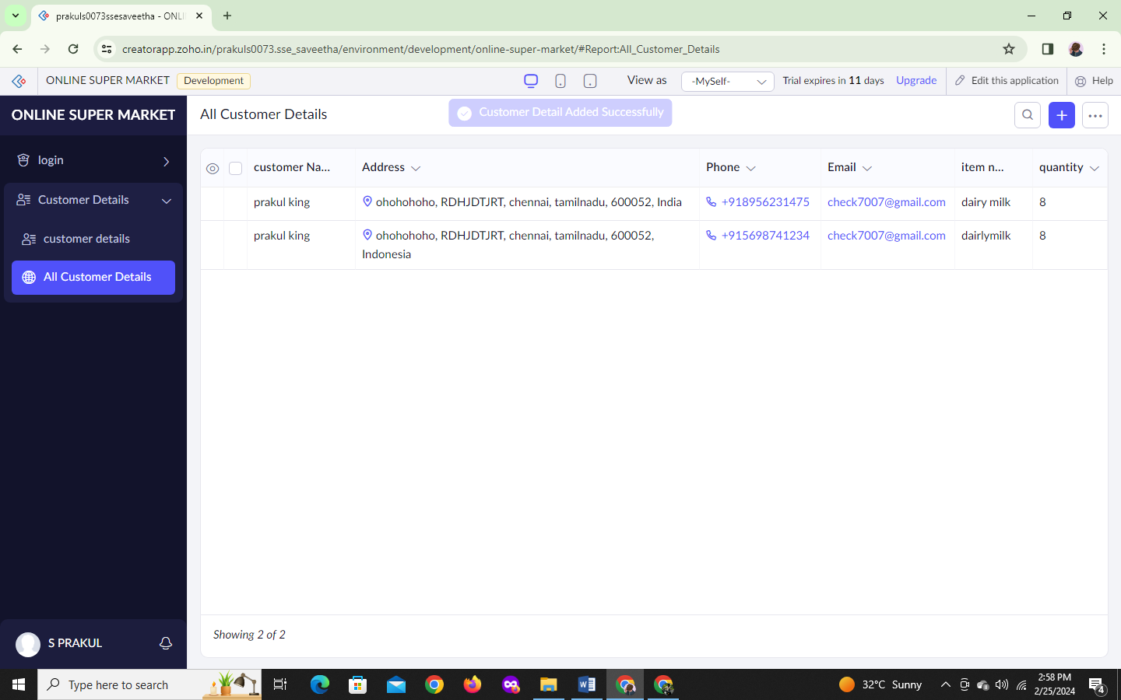

STEP 14: Select with existing form Create form as add stock items details.

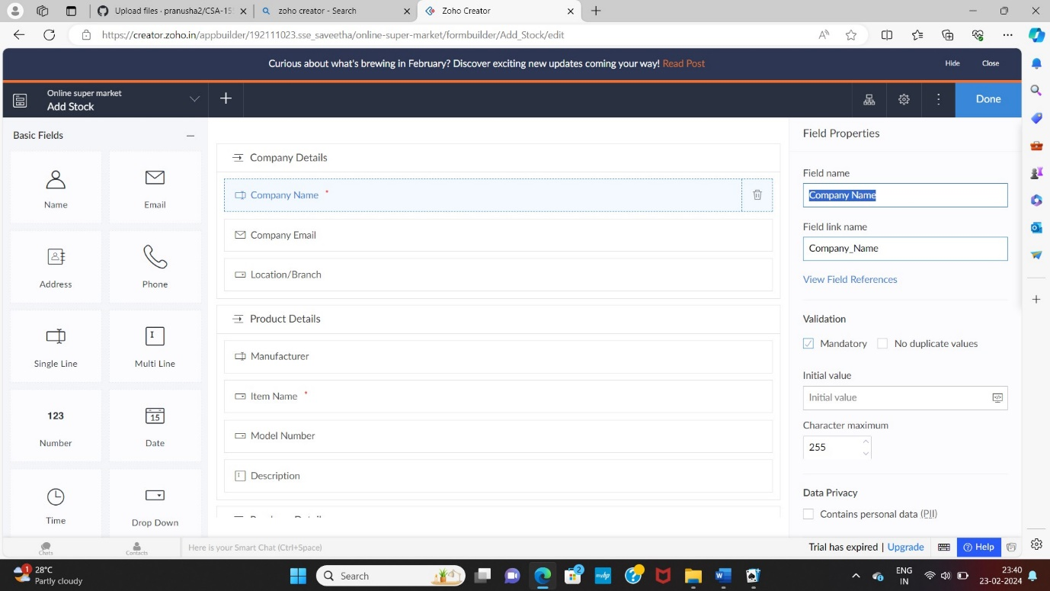

STEP 15: The form has been created as add stock.

Choose the fields.

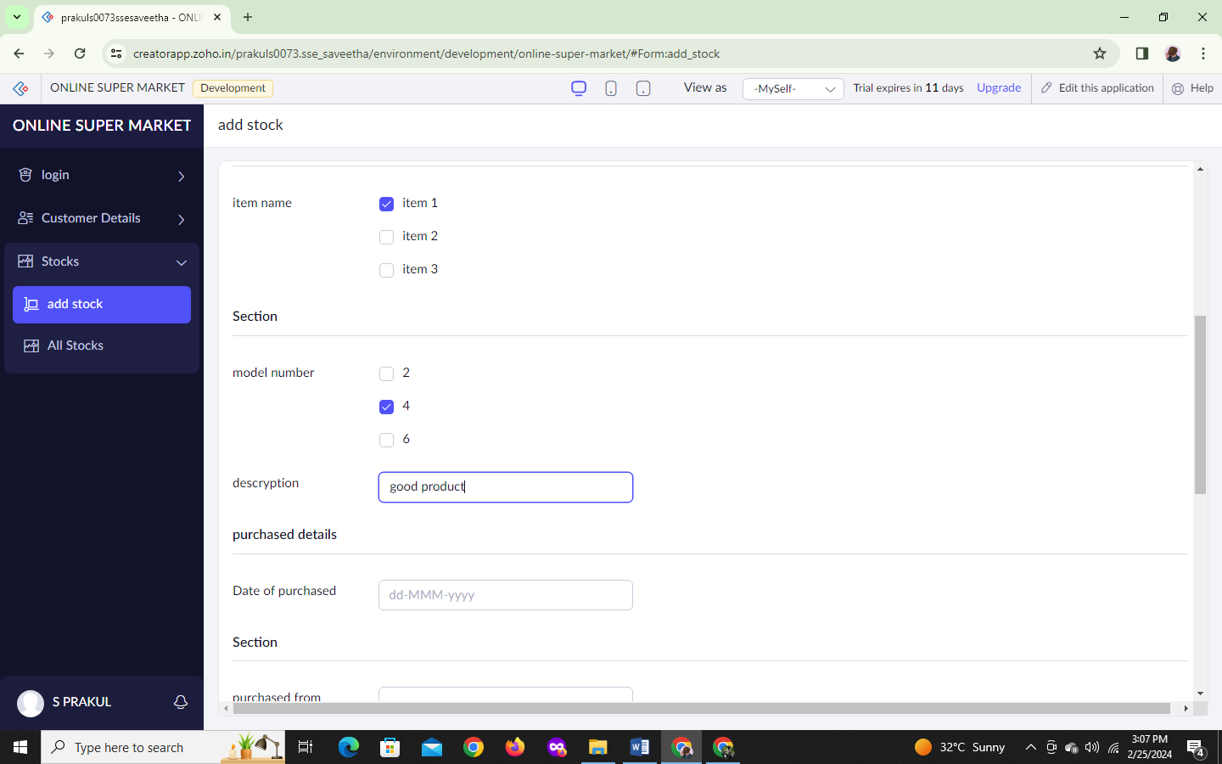

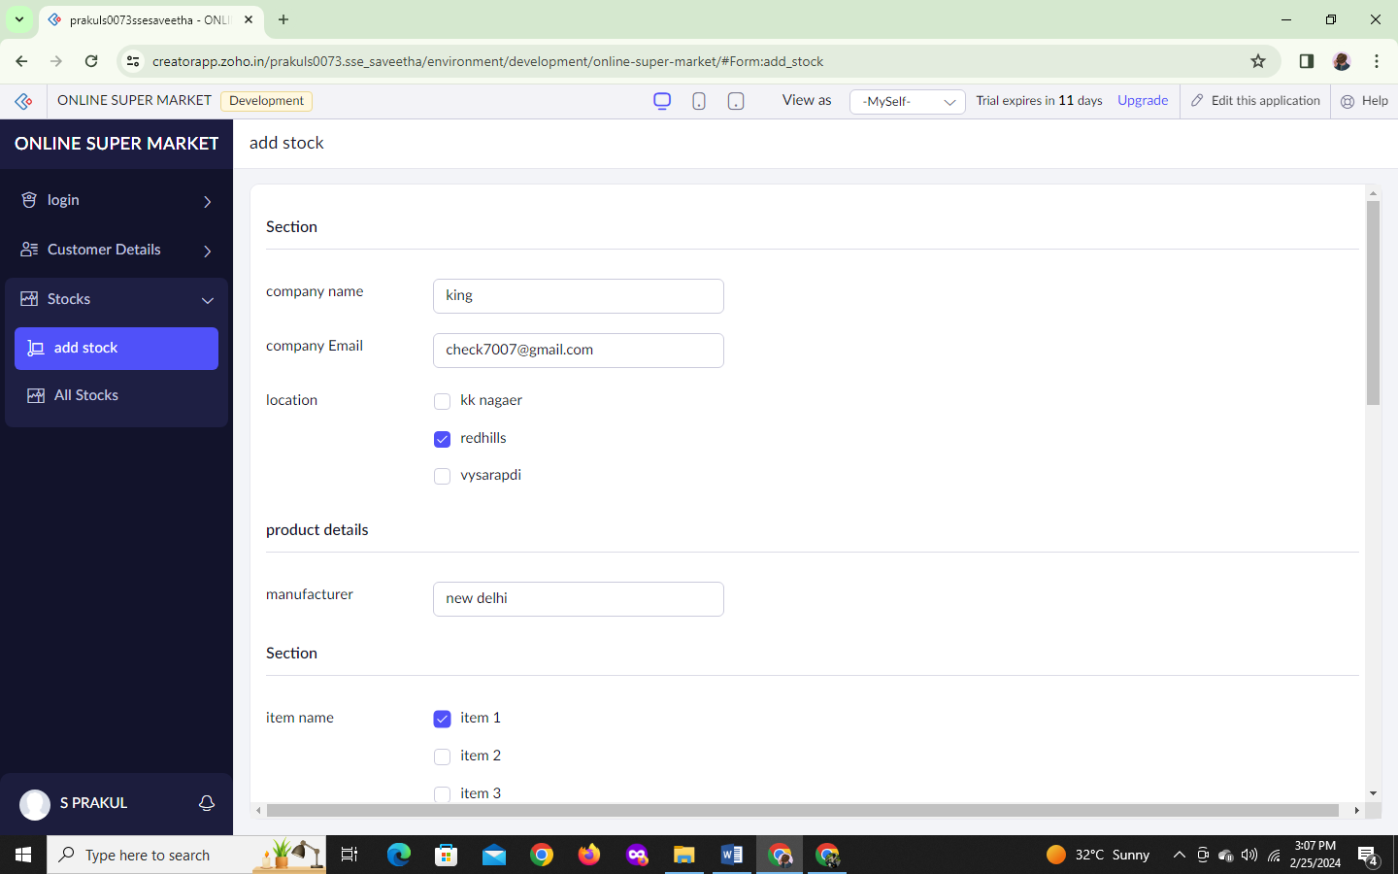

STEP 16: Click Access Development Live and enter the details to access.



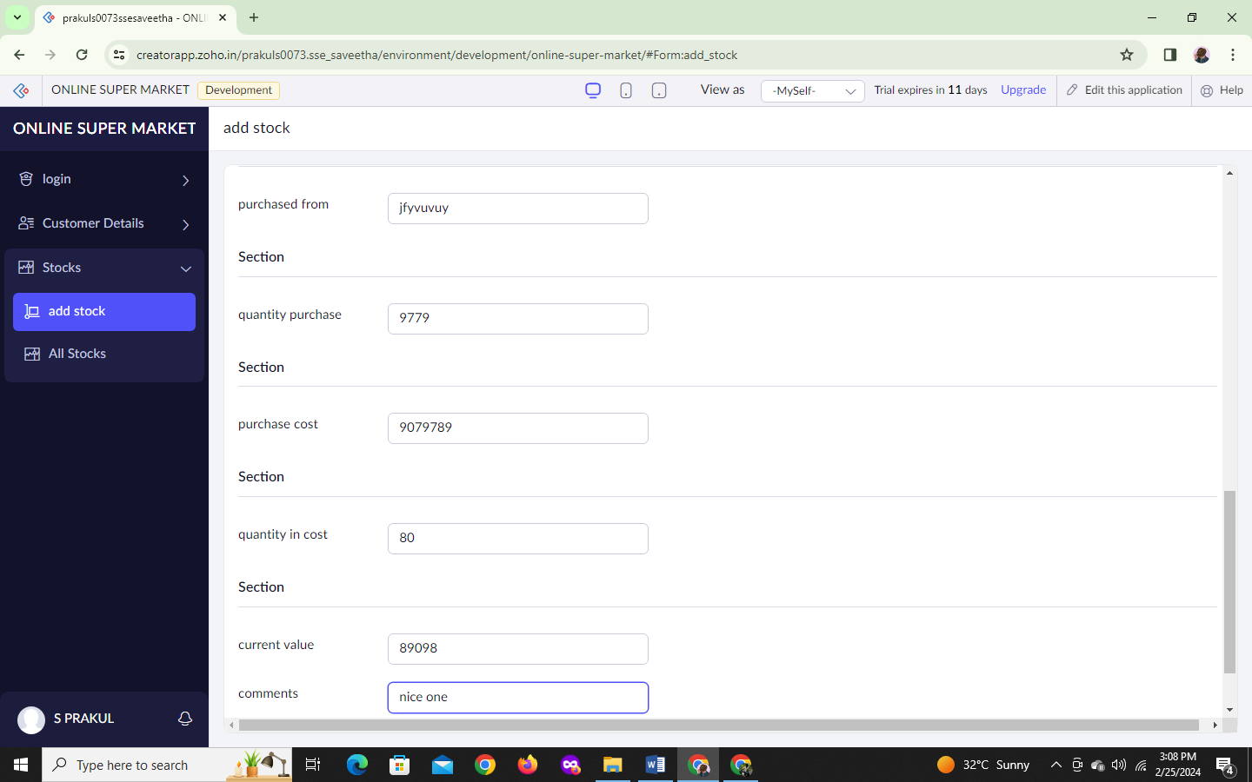

STEP 17: The report has been registered in the customer details report.

